**Hand in (deadline): Thursday 16/3 2017 at 23.55 on moodle.**

**Database design and the E/R model**

**1**  (~Exercise 7.14)

Explain the distinctions among the terms primary key, candidate key, and superkey.

Keys:

Keys is the values of the attribute values of a tuple must be such that they can uniquely identify the tuple. In other words, no two tuples in a relation are allowed to have exactly the same value for all attributes.

A **superkey**

is a combination of attributes that can be uniquely used to identify a database record. A table might have many superkeys. Candidate keys are a special subset of superkeys that do not have any extraneous information in them.

For example, the ID attribute of the relation instructor is sufﬁcient to distinguish one instructor tuple from another. Thus, ID is a superkey. The name attribute of instructor, on the other hand, is not a superkey, because several instructors might have the same name.

A **primary** **key**

Is the attribute or combination of attributes that uniquely identifies a row or record in a relation is known as primary key.

A **candidate** **key**

A relation can have only one primary key. It may contain many fields or combination of fields that can be used as primary key. One field or combination of fields is used as primary key. The fields or combination of fields that are not used as primary key are known as candidate key or alternate key.

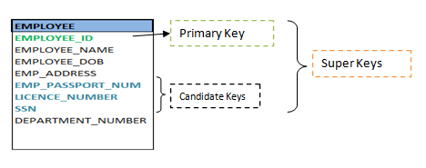

**2** (~Exercise 7.15)

Construct an E-R diagram for a hospital with a set of patients and a set of medical doctors. Associate with each patient a log of the various tests and examinations conducted.

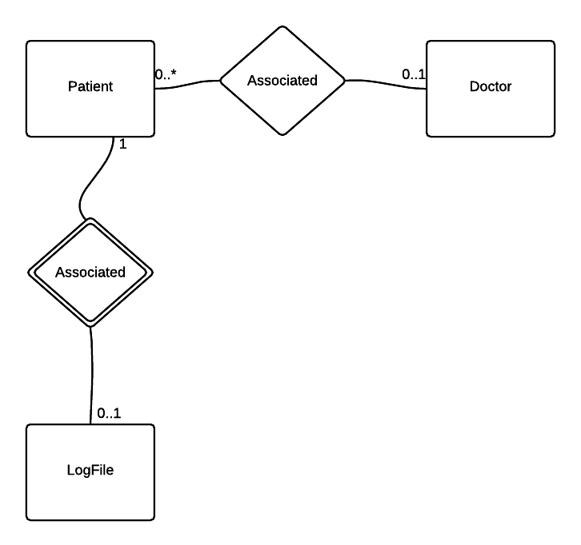

**3** (~Exercise 7.16)

Construct appropriate relation schemas for each of the E-R diagrams in Practice Exercises 7.1 to 7.2.

Schema for 7.1:

Customer(Cust_ID, Name, Address)

Car(License_no,model, Cust_ID)

Accident(report_id, date, place, Licens_no)

Policy(policy_id, Licens_no)

PreminumPayment(Payment_no, due_date, amount, received_on, policy_id)

Schema for 7.2:

Match(Match_id,date,stadium,opponent, own_score, opp_score)

Player(player_id, name, age, season_score)

**4** (~Exercise 7.18)

Explain the difference between a weak and a strong entity set.

The difference between weak and strong are that a weak an entity which existence depends on some other entity type. (Example: Employee – Relatives) If the Employee are not in the system, the relative does not make sense to exists.

The Strong entity has a primary key and all tuples in the set are distinguishable by that key. A weak entity has usually no primary key.

**Relational Database design**

**5** (~Exercise 8.21)

Normalize the following schema, with given constraints, to 4NF.

*books(accessionno, isbn, title, author, publisher)*

*users(userid, name, deptid, deptname)*

*accessionno→isbn*

*isbn→title*

*isbn→publisher*

*isbn→→author*

*userid→name*

*userid→deptid*

*deptid→deptname*

**Answer:**

books(isbn, title, publisher, author)

accession(accessionno, isbn)

users(userid, name, deptid)

departments(deptid, deptname)